7PAM2000 Applied Data Science 1 Assignment 1: Visualisation

**Data Set Link –**

<https://projects.fivethirtyeight.com/coronavirus-polls/>

<https://github.com/fivethirtyeight/covid-19-polls>

Table of Contents

Introduction 2

Research Question 2

Approval Votes for Vaccination by Party and Date: 3

Sample Size by Subject: 4

Result: 5

Conclusion: 6

Table of Figures

Figure 1: Approve votes for vaccination by each party 3

Figure 2: Sample Size Total By Subject 4

Figure 3: Top 10 Sponsors with Highest Average Disapproval Ratings 5

# Introduction

The dataset available on the FiveThirtyEight website provides a comprehensive overview of the public opinion surrounding the COVID-19 pandemic in the United States. The polls are conducted by various polling organizations, including research institutes, media outlets, and political action committees, among others. The dataset is updated on a regular basis, providing real-time insights into how public opinion is shifting as the pandemic evolves.

The polls cover a range of topics related to the pandemic, including public perceptions of the government's response to the crisis, confidence in the healthcare system, and willingness to take preventive measures like wearing masks and practicing social distancing. Other polls focus on attitudes towards vaccination and the COVID-19 relief measures passed by the government, including stimulus checks and unemployment benefits.

The dataset provides a wealth of information for researchers, policymakers, and anyone interested in understanding how the pandemic is affecting the public's attitudes and behaviors. The website also provides interactive visualizations and analysis of the data, making it easy to explore the trends and patterns in the polls over time

Overall, the Coronavirus-related polls dataset from FiveThirtyEight is a valuable resource for anyone looking to gain a deeper understanding of how the pandemic is impacting public opinion and shaping policy decisions in the United States.

The 'subject' column identifies the person or party whose handling of covid-19 is being evaluated for approval polls, while it identifies the aspect being evaluated for concern polls, such as concern-infected or concern-economy. The 'party' column provides information about the political affiliation of the respondents. The 'startdate' and 'enddate' columns denote the starting and ending dates of the poll, respectively. The 'pollster' column indicates the organization that conducted the poll, and the 'sponsor' column shows the organization that sponsored the poll. The 'samplesize' column denotes the number of respondents who participated in the poll. The 'population' column provides information about the population sampled for the poll, such as adults, registered voters, and likely voters. The 'tracking' column is a boolean value that indicates if the poll is a tracking poll or not. If 'tracking' is true, then the pollster is releasing data with overlapping samples. The 'text' column shows the text of the question that was asked to the respondents, and the 'url' column provides a link to the poll.

# Research Question

Following Research question is been answered by using the Dataset.

• Approve votes for vaccination by each party as per date using (Line Chart).

• What is the sample Size as per the Subject (using Pie Chart) ?

• Which are the highest top 10 sponsors or Publication that have the largest disapproval votes. (Using Bar graph)

In this research project, analyse the approval votes for vaccination by party and date. Thereby visualize the approval votes for each party using a line chart and examine the sample size for each subject using a pie chart. Research also identifies the top 10 sponsors or publications with the largest disapproval votes using a bar graph.

# Approval Votes for Vaccination by Party and Date:

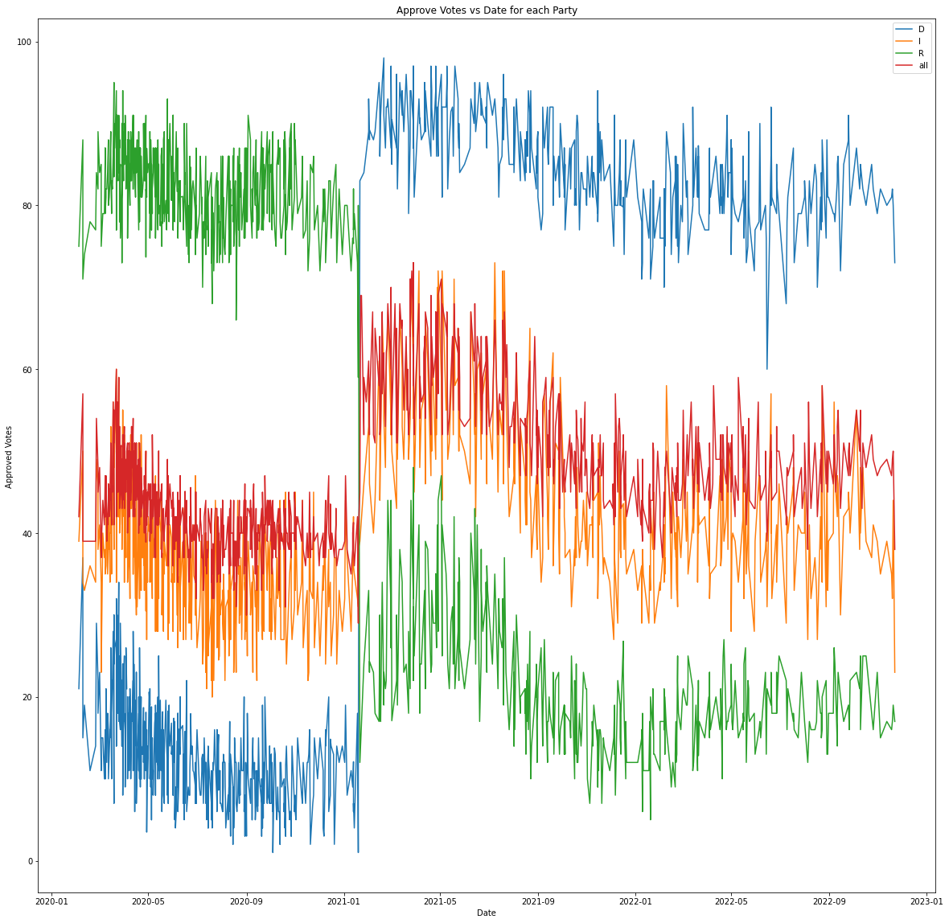

Figure : Approve votes for vaccination by each party

Here plot the approval votes for each party over time using a line chart. The x-axis represents the date, and the y-axis represents the percentage of approval votes for vaccination. Here group the data by party and connect the points with lines to show the trend in the approval votes over time. From the analysis its been shown that from the starting date that is 2020-01 the Republic part has the highest number of approved votes but after the date 2021-01 the Democratic Part takes a sharp lead and thus after that is been the highest party till poll last date.

# Sample Size by Subject:

A pie chart to visualize the sample size for each subject. The pie chart shows the percentage of the sample size for each subject, such as Trump, Biden, concern-infected, concern-economy, and others. From the visualization it been clear that Trump has the highest sample Size for votes as it occurs for the 83.4 %. While Biden has only 16.6 % of sample size.

Figure : Sample Size Total By Subject

Top 10 Sponsors or Publications with the Largest Disapproval Votes:

Here Bar Graph is used to identify the top 10 sponsors or publications with the largest disapproval votes. The x-axis represents the name of the sponsor or publication, and the y-axis represents the percentage of disapproval votes. The data is sorted by the highest of average of disapproval votes and show the top 10 sponsors or publications using horizontal bars. From the analysis it been clearly shows that the Highest disproval rating is from the ABC news with rating around 80 and the second Highest is from the Survey Center on American life which is a research based group that survey focusing on critical issues on American Life.

Figure : Top 10 Sponsors with Highest Average Disapproval Ratings

# Result:

The analysis shows that the Democratic Party has taken a sharp lead in approval votes for vaccination since 2021-01 and is the highest party in terms of approval votes till the poll's last date. Additionally, the analysis shows that Trump has the highest sample size for votes, with a percentage of 83.4%, while Biden has only 16.6% of the sample size. Finally, the top two sponsors or publications with the largest disapproval votes are ABC news and the Survey Center on American life, with disapproval ratings of around 80 and 60, respectively.

# Conclusion:

The findings suggest that the Democratic Party has a higher approval rating for vaccination than the Republican Party. Additionally, the findings also indicate that there is a significant difference in sample size between Trump and Biden, with Trump having a much larger sample size. Finally, the top sponsors or publications with the largest disapproval votes indicate that the media plays a significant role in shaping public opinion on vaccination. These findings can be useful for policymakers and health officials in designing effective vaccination campaigns and addressing concerns related to vaccination.